1.8: What's Next?

#### **Introduction**

Congratulations! You’ve reached the final Exercise of the UX Fundamentals Course! Not only have you created your own app designs from initial research all the way through prototyping and testing, you’ve also presented and defended your design decisions, explaining why you built your app in a particular way. By learning the design thinking process and using it to perform each step throughout the course, you’re one step closer to thinking like a designer!

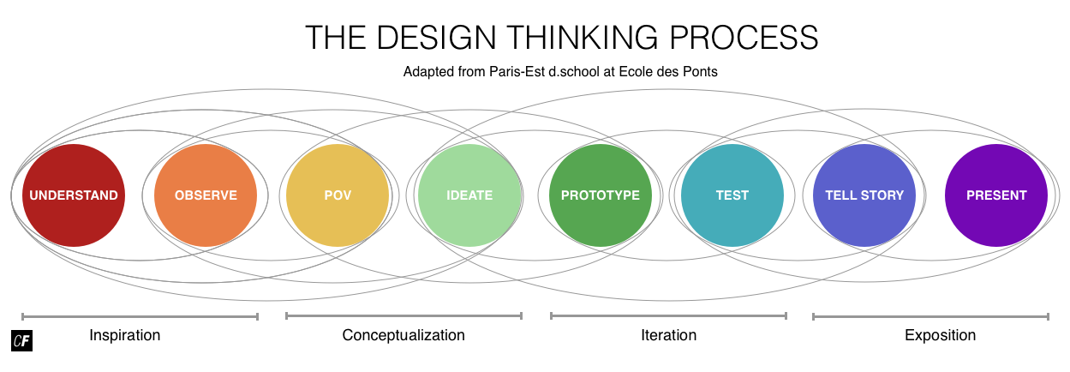

What’s next? You might be thinking about a complete career change, or perhaps you simply want to integrate solid design fundamentals into your existing role at your workplace. Regardless of your future plans, it’s important to have a realistic awareness of what you know and don’t know when it comes to the world of UX design. Even more important is knowing what you enjoy and don’t enjoy doing. Many people advertise themselves based on their current skill set even if their current skill set doesn’t excite them. If you’re a Microsoft Excel whiz, for example, but don’t actually enjoy working with Excel, don’t advertise it on your resume or in the office—all you'll do is paint yourself into a corner of endless cells and equations.

It’s also of critical importance to be useful. Do your best to leverage your strengths so you can add value to other people’s lives. Instead of asking “What would make mehappy?” flip it around and ask “What would make other people happy?” “How can I be useful?” and “What does the world need?”

For many people, user experience design is a great way to reconcile personal passion and mission with vocation and profession, as it allows them to solve real problems for real people. There will always be problems to solve. Learning to approach problems through design thinking and human-centered design is a fun and effective way to tackle problems that exist in our environment.

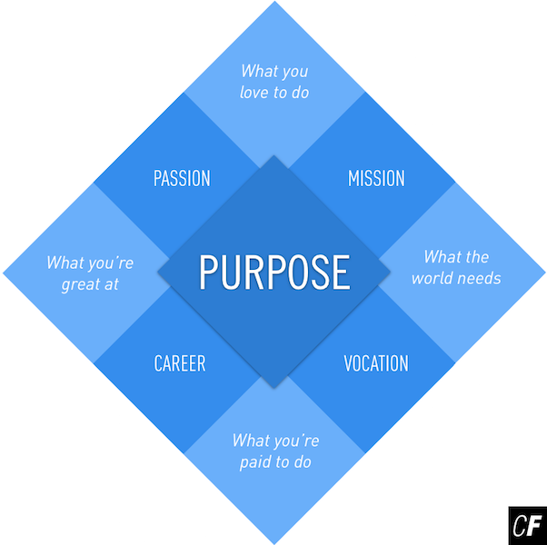

If UX designers were to write a mission statement, it might look something like this:

“Our mission is to listen. Our goal is to understand the complexity of systems we create and the people that use them. Our work is inspired by humans and created for humans to improve the human condition.”

If this mission statement resonates with you, there’s a spot just for you in the world of UX design. The desires to tackle challenges, develop soft skills, and learn solid design fundamentals are all requirements to becoming an effective UX designer. The key to getting there is to develop a broad understanding of the field and of yourself so you can find purpose and contribute in a meaningful way, either as a designer or as someone who understands how to use design in your own role.

In this Exercise, we’ll explore a few different frameworks and activities to define the shape of your design profile so you can continue your personal and professional education with a clearly defined purpose.

#### **The Shape of a Designer**

Design is all about communication, which comes in all forms—verbal, nonverbal, written, and visual. Designers are required to use all forms of communication to engage with colleagues and customers to first understand the problem and then visualize potential solutions. It’s difficult to design in a vacuum, especially when adopting human-centered design principles. An artist looks at the world through their own eyes. They express themselves on the canvas, shouting “This is me! This is how I see the world!” In contrast, a designer must see the world through other people’s perspectives, which is why human-centered design principles are so important.

Soft skills such as problem solving, adaptability, critical observations, and conflict resolution are crucial when reconciling business, customer, and technical needs. For a system and solution to work, effective UX and UI designers must understand the business and the people for which they’re designing. To do so, a certain level of empathy and collaboration is required. The ability to actively listen to people, engage in open communication, and accept critique is of critical importance.

IDEO Executive Tim Brown used the visual metaphor “T-Shaped” to describe the desired profile for new hires in interdisciplinary teams in creative fields. Soft skills, coupled with basic industry knowledge and technical expertise, provide the foundation for your profile as a designer.

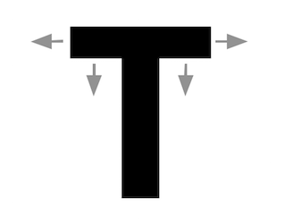

###### **Source:**[**Karel Vredenburg**](http://www.karelvredenburg.com/home/)

According to Brown:

“The vertical stroke of the ’T’ is a depth of skill that allows them to contribute to the creative process. That can be from any number of different fields: an industrial designer, an architect, a social scientist, a business specialist, or a mechanical engineer.

The horizontal stroke of the ’T’ is the disposition for collaboration across disciplines. It is composed of two things. First, empathy. It’s important because it allows people to imagine the problem from another perspective—to stand in somebody else’s shoes. Second, they tend to get very enthusiastic about other people’s disciplines, to the point that they may actually start to practice them. T-shaped people have both depth and breadth in their skills.”

This UX Fundamentals Course was a great way to begin building the horizontal foundation of your “T.” Once you’ve developed a solid foundation of the fundamentals, you can dive into something more specific—something you’re particularly good at or something you really enjoy.

#### **Your Design Profile**

All of this leads to the question—how does one discover what they’re good at or enjoy doing? Let’s work through a few exercises that look at your experiences and goals.

What have you enjoyed in previous positions? What are your skills in design and what would you like to work on? How can you use your network to support your ambitions?

Creating your Design Profile asks you to do the following tasks:

1. Resume Scrub [20 minutes]
2. Future Portfolio [30 minutes]
3. UX Quadrant Exercise [30 minutes]
4. It Takes a Village [30 minutes]

You can pause and do the work as you go along in each of the following sections, or you can read through to the end and come back once you're finished. We’ve included the time each task will take so that you can plan out how best to tackle them. Let's look into each point more closely.

#### **1. Resume Scrub**

Time estimate: 20 minutes

This resume exercise is pretty straightforward. We'll start by taking an inventory of your current skills and capacities. Print out your resume or CV, grab some pencils and highlighters, and read through your resume. Then, complete the following steps:

##### **Audit Your Current Resume: 10 minutes**

* **Strike through** any projects, skills, and experiences you didn’t or don’t actually enjoy.
* **Highlight** or **underline** projects, skills, and experiences you found interesting and/or enjoyed.
* From what you've highlighted or underlined, **circle** the projects, skills, and experiences where you really excelled—instances where you were able to add maximum value to the project and to the people around you.

Holding up so far? This short exercise should bring some clarity to the skills you currently have and what types of projects you enjoy. Now it's time to look ahead and plan out your future resume.

##### **Prototype Your Future Resume: 10 minutes**

Grab a blank sheet of paper and a pencil. It’s time to prototype your future resume! This could be five, ten, or even fifteen years down the line. Even if you're not planning on changing jobs or careers anytime soon, this is a fantastic way to map out how you want to continue building your skillsets and seek out projects meaningful to you.

By taking this course, it’s clear you have a strong interest in UX and possible aspirations to be a UX designer, but where do you see yourself working and what type of UX work do you see yourself doing? For example, as a lead UX designer at a top company like Google or as an independent UX researcher for nonprofits? Relate this to your interests and skills and think about the type of company you’d like to work for. Take a look at job sites for the types of UX jobs available, combine this with the companies you’re interested in, and add it all to your future resume! The point is to dream big and imagine the type of job you’d like to have in the future. If you want to be a lead UX designer, add a job beneath that as a junior UX designer. Map out how you’ll work your way up and add jobs in-between to get yourself to that point.

And what about classes? Add your CareerFoundry course, then think about any other courses you might take to further your education. By making your resume look real, it will feel real and attainable. You'll be able to refer back to it as a source of motivation down the road.

Below are two examples to get you started. Refer to them as examples for how you’d structure the content of your resume. Remember that everyone’s design story is different and how you tell yours is up to you. You might also want to discuss the best approach to take with your Mentor.

* [Vittoria's Resume](https://s3.amazonaws.com/coach-courses-us/public/courses/ux-fundamentals/E8/5_Resume_Vittoria.pdf)
* [Mike's Resume](https://s3.amazonaws.com/coach-courses-us/public/courses/ux-fundamentals/E8/5_Resume_Mike.pdf)

Note that your resume should go above and beyond these examples—it should include your future job in the UX field in addition to your past jobs and education; however, these will give you a good idea of where to start!

#### **2. Future Portfolio**

Time estimate: 30 minutes

Now that you have a prototype of your resume, let’s take a closer look into the projects and activities involved in achieving success. What types of projects do you enjoy working on and in what capacity? Do you prefer working on one product at a big company or startup, or on a variety of different projects as a freelancer? What about projects in the nonprofit sector or the arts? Again, don’t be afraid to get creative and dream big.

##### **Prototype Your Future Portfolio: 30 minutes**

* Take a look at the previous step. Make a note of the types of projects you enjoyed previously and the career path you outlined in your future resume.
* Sketch out **four short case studies** you’d like to have in your portfolio, including a specific company, industry, description, and outcome. This will provide the foundation for further education and professional positioning.

Think of your case studies as specific projects you’ll work on in the jobs listed in your future resume. If, for instance, you included a lead UX designer position for Google, what kind of project would you work on there? A redesign of their Gmail UX or the UX for the next Google phone? Try thinking of at least one project you could see yourself working on for each of the jobs you included in your future resume. Write a short description of what the project would entail, the role you’d play, and the resulting success. This is your chance to imagine your dream projects.

#### **3. UX Quadrant Exercise**

Time estimate: 30 minutes

Let’s take a look at the UX Quadrant Model for a more concrete idea of the skills, methods, and techniques you need to learn to make your future resume and portfolio come to life. This will build on Warren Hutchinson’s UX Quadrant Diagram (a modified version of the quadrant you’ve seen several times throughout this course) and [Jason Mesut’s profiling exercise](http://www.slideshare.net/jasonmesut/sell-yourselves-better-employing-ux-talent/25-Understanding_yourshape_and_how_you).

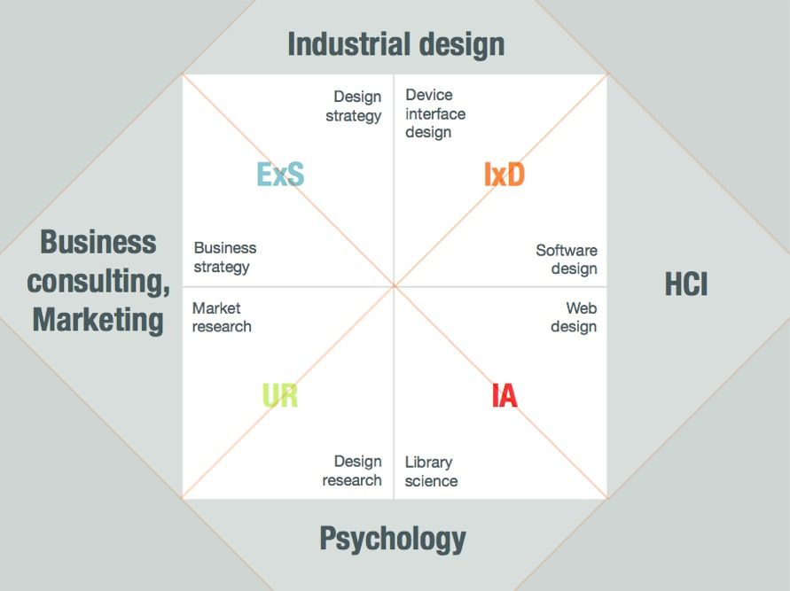

###### **Source:**[**Amplify Design**](https://medium.com/amplify-design/shapes-of-ux-designer-ad047bddac7f)

Upon zooming out from the quadrant, you'll see the traditional fields of industrial design, human computer interaction (HCI), business consulting/marketing, and psychology come into view. Zooming in, you'll notice that each quadrant is broken down into two distinct fields. It’s likely that you already have some direct or indirect experience in one of these fields, but let’s break them down briefly as a refresher.

Industrial Design includes elements of Experience Strategy (ExS) and Interaction Design (IxD). You will likely find yourself occupying this side of the quadrant quite often through work relating to design strategy and device interface design. The next area, HCI, includes both IxD and Information Architecture (IA). As a UX designer, you could spend time working on software design, but are more likely to work on web design projects.

Psychology is a critical aspect of practicing human-centered design, including a mix of both information architecture and user research, for tasks relating to library science and design research.

And finally, the business consulting/marketing portion includes a mixture of user research and ExS. If you find yourself especially fond of the researching aspect of UX design, and less interested in artistic creations, you might feel the most comfortable seeking out jobs that ask for your knowledge for market research and to influence and inform business strategy.

##### **Brainstorm Your Existing Experience: 10 minutes**

Think back to the many jobs, projects, or even classes you’ve taken on in your life. Can you think of anything that would be relevant to one of these fields? If so, take a pencil and jot down some of the skills you might be able to bring to the table within each section.

If nothing immediately comes to mind, write down, instead, skills that you enjoyed learning throughout this course and would like to explore in greater detail. Did you enjoy interacting with people and conducting interviews? How about sketching interfaces and design patterns? Go ahead—write it all down!

##### **Draw Your Design Profile: 20 minutes**

Now for the fun part. It’s time to visualize your personal shape as a UX Designer. If you wish, you can use or print out the design profile template provided ([PPT](https://s3.amazonaws.com/coach-courses-us/public/courses/ux-fundamentals/E8/designprofile.pptx), [Keynote](https://s3.amazonaws.com/coach-courses-us/public/courses/ux-fundamentals/E8/designprofile.key), [PDF](https://s3.amazonaws.com/coach-courses-us/public/courses/ux-fundamentals/E8/designprofile.pdf)).

Complete the following steps:

1. Rank your ability from 1-5 (1 indicating a low level of proficiency, and 5 indicating a high level of proficiency) within the four main categories: Experience Design Strategy (ExS), Interaction Design (IxD), User Research (UR), and Information Architecture (IA).
2. Plot your scores on the diagonal lines. Connect the dots to draw your current shape according to where you rank in each category.
3. Draw arrows in the directions you’d like to go in the future. A long arrow indicates increased emphasis.
4. Make a list of 3–5 steps on how you’ll continue your education to achieve progress in those areas and create your future shape as a UX designer.

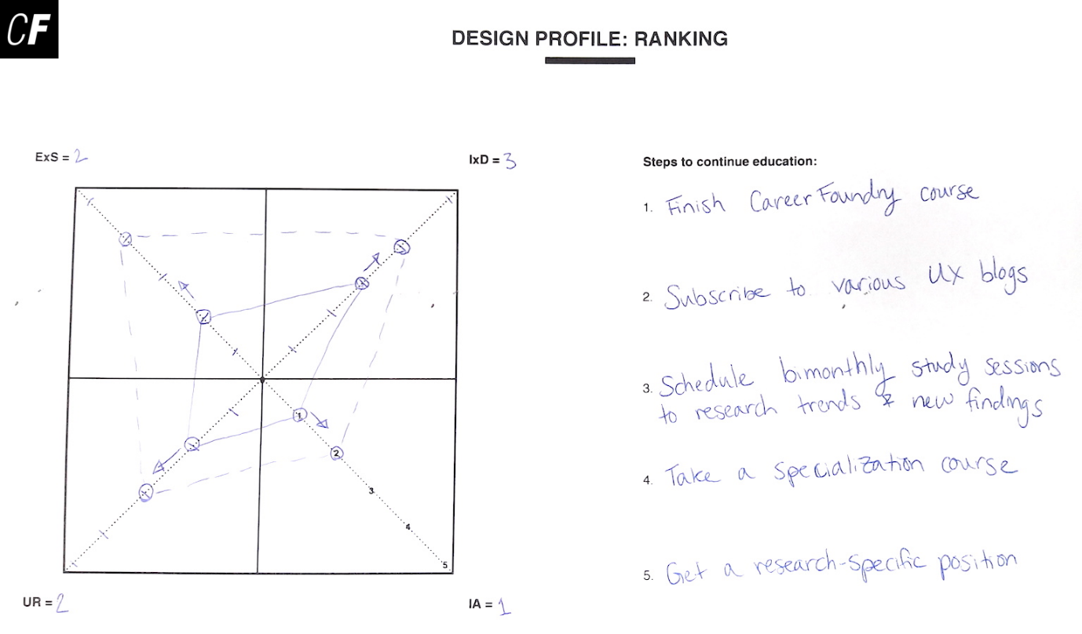

If you need more ideas for various skills and techniques included in the role of a UX designer, take a look at the 30 elements in the second biggest ring in the below UX Wheel. The decision to use the wheel shape is intentional, as it accurately visualizes the cyclical and continual form of the design process. If, however, the wheel has your head spinning and you prefer a list of skills and techniques, check out this comprehensive list of [UX Design Methods and Deliverables](https://uxdesign.cc/ux-design-methods-deliverables-657f54ce3c7d#.s67p0p4uq).

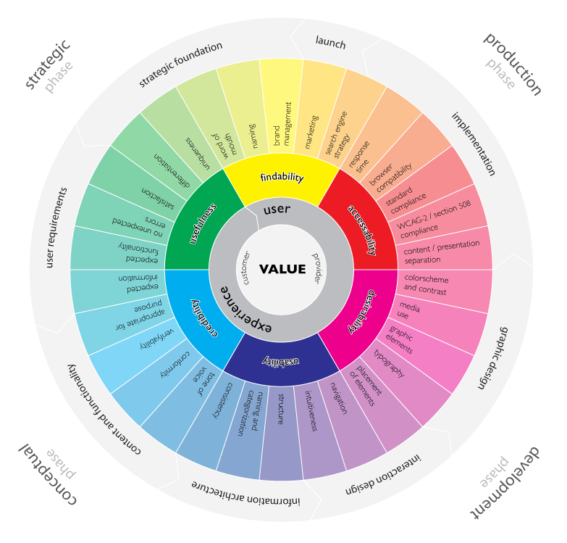

###### **Source:**[**Magnus Revang**](http://userexperienceproject.blogspot.de/2007/04/user-experience-wheel.html)

#### **4. It Takes a Village**

Time estimate: 30 minutes

So far, this lesson has been all about you. A good sense of self is incredibly important not just for UX designers, but for any profession. The ability to be self-aware when designing your education and professional aspirations will give you a goal that is not only attainable but self-fulfilling. The previous exercises should have highlighted things you’re skilled at, as well as a few things you may not be proficient in, yet, but that you enjoy.

With that said, it takes a village to learn new concepts and change careers (and a lot of courage, to boot!). Now that you know who you are and what you want, it’s time to reach out. Create and curate your own village of peers and experts to help you along the way.

##### **Build a Village of Peers and Experts: 30 minutes**

Take a look at the good parts of your current resume. Were there any people who were inspiring or helpful during these projects or at these jobs? Get in touch with them. Let them know what you’re up to. Thank them for their inspiration and support on your previous projects. Write them an email or LinkedIn recommendation. Follow them on Twitter—whatever! This is a good opportunity to practice gratitude and stay in touch with meaningful people in your life.

Take another look at the good parts of your current resume. Have you worked with anyone in your field of interest? Get in touch with them, as well. Let them know what you’re up to and ask for advice on how to continue your education.

Lastly, take advantage of the CareerFoundry community, including [The UX School's Facebook group](https://www.facebook.com/groups/TheUXSchool/), CareerFoundry's UX community for people wanting to explore and ask questions about UX. It's an online village of peers and experts, alike, and a great resource for advice, inspiration, and networking.

#### **Summary**

Whew! Taking a good look at yourself can be a lot of work, but hopefully you found it rewarding and exciting. As you’ve learned throughout this course, the work of UX and UI designers encompasses the entirety of a user’s experience with a product or service. This can include any number of topics from human emotions to how people interact with and interpret information structures. It’s a great big field to get involved in! Whatever the level of involvement you choose, we hope you’ll use what you’ve learned to build something better for those around you. We also hope you'll have a blast doing it!

Remember that we’re here to help you in your career-development journey no matter where the winds of change may take you. Stay in touch, stay engaged, and let us know how we can help you take shape as a UX designer!

#### **Resources**

* [UX Methods](https://www.usability.gov/how-to-and-tools/methods/index.html)
* [UX Techniques](http://uxmastery.com/resources/techniques)
* [UX Design Methods and Deliverables](https://uxdesign.cc/ux-design-methods-deliverables-657f54ce3c7d#.s67p0p4uq)
* [Great Design Portfolios are Great Stories](https://medium.com/@span870/great-design-portfolios-are-great-stories-7bb2617cd7ab#.3ck6l1i7m)
* [Jason Mesut Profiling Exercise](http://www.slideshare.net/jasonmesut/sell-yourselves-better-employing-ux-talent/25-Understanding_yourshape_and_how_you)